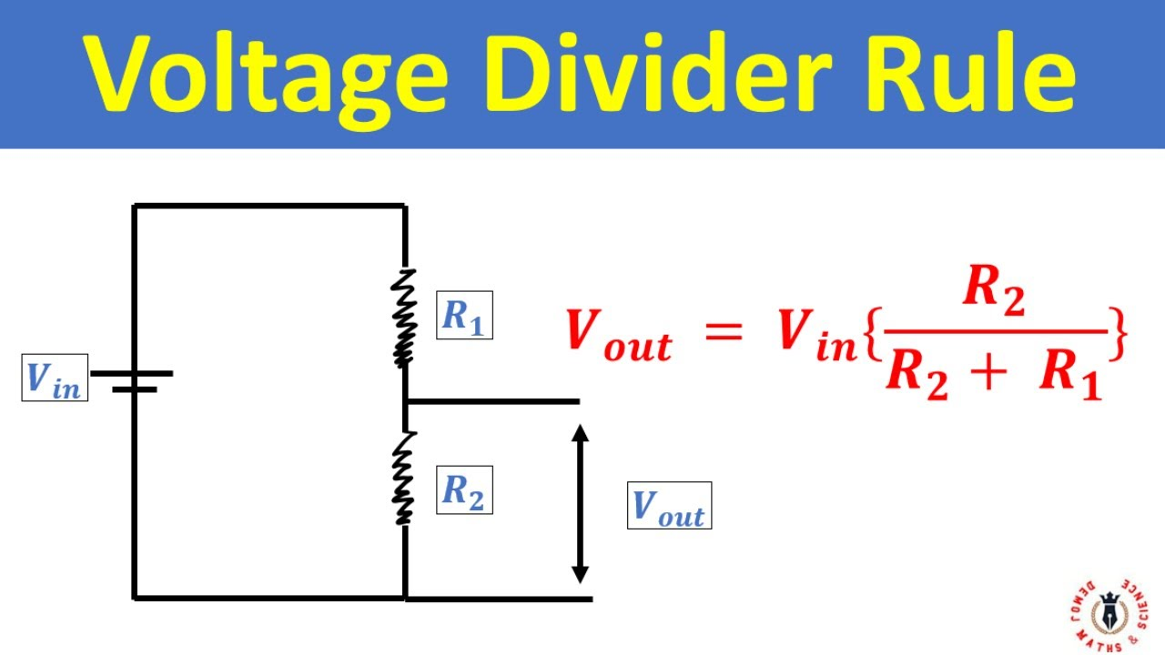
USING A POTENTIOMETER: SPECIFICATIONS B10K FACE:
- A potentiometer works by using a sliding contact (wiper) to move along a resistive element, which adjusts the electrical resistance and voltage output. By applying a voltage across the two ends of the resistive element, the position of the wiper determines the voltage at the output terminal, allowing it to function as a voltage divider or a variable resistor
- Left most: Vin:
- Middle: Variable Output:
- Right most: Vout.
The potentiometer acts like R1 and R2 in the diagram, resistor in series. R1 is created by length from Vin to the wiper(Variable Output). R2 is created by the remainder of the resistive track(from the end of wiper to end of resistor track) + the resistor to ground(more Details about this later).
DETAILS:
- We define Vin in the voltage divider formula to equal 3.3 volts for scaling of potentiometer.
- We are using a B10K potentiometer
- We define RAW as resistance from Vin to Wiper(variable output)
- We define RWB as resistance from Wiper(variable output) to End of resistive track (Vout)
- We define Rgnd as resistor connecting End of resistive track (Vout) to ground.
  - Notice Vout needs a current limiting resistor as it connects straight to ground. However, the resistor value does NOT affect the voltage divider equation and we do not need to factor this in,
  - GOAL: at 50 percent resistance: to create a voltage divider that limits 50 percent of the voltage: variable output from a 3.3 V input becomes 1.65 Volts.
Using the formula and the defined statements:
VIN = VOUT( RWB + Rgnd ) / [( RWB + Rgnd ) + RAW]
1.65 = 3.3( RWB + Rgnd ) / [( RWB + Rgnd ) + 5k]
(0.5) = (5000 + Rgnd ) / [( 5000 + Rgnd ) + 5000]
0.5 × (10000 + Rgnd) = 5000 + Rgnd
5000 + 0.5Rgnd = 5000 + Rgnd
5000 + 0.5Rgnd - 5000 = Rgnd
0.5Rgnd = Rgnd
- This approach does not work. A new approach is needed:
NOTICE: We only need Rgnd because at maximum wiper sweep, variable out will have resistance but not Vout, meaning infinite current to Vout. We need to introduce a current limiting resistor before the resistive strip.
Therfore: Solution
3.3V → 1kΩ → Terminal A
↓
R_AW → Wiper → LED → Ground
↓
R_WB → Terminal B → 1kΩ → Ground
This correctly produces 50% voltage from 3.3 of a potentiometer at 50% wiper sweep.
- Consideration: Multimeter probing of this to Green LED shows voltage of 2.2 volts. This is because the LED is loading down the circuit so heavily that the voltage divider isn't working as intended. This means that the voltage divider is working as intended. But the LED is drawing so much current that it overwhelms the voltage divider. V=IR and electro magnetic affect of multiple resistors / PWM.
Recommended for High independence input. Because high independence inputs don’t allow current, but only take voltage, allowing most of current to safely pass to ground.
3.3V → Terminal A
↓
R_AW → Wiper → To Waveform Generator Input
↓
R_WB → Terminal B → Ground

